Reflective Project

Research Quick-Reference
With info from IB Reflective Project Guide and Teacher Support Material on IBO.org

📌Book a session in the Writing Lab at https://lamar.mywconline.com/🎯
Contact Dr. Lowe at Annie.Lowe@HoustonISD.org

Ethics in career-related context
From their career-related study, students identify an issue of interest then explore the ethical dimension associated with the issue in order to arrive at a focused ethical dilemma. The reflective project’s primary focus is the ethical dilemma embedded within the issue, not the issue itself.

Students undertake research and analysis on the chosen ethical dilemma. This research will include consultation with the local and/or global community.

Linking the reflective project to the career-related studies of students provides a way for them to explore ethical dilemmas in real-life situations.

Preliminary Research
(the search and discovery phase)

Finding your topic Gathering examples for analysis
Ethical issue for focused dilemma | Contemporary real-life examples  in local and/or global communities
Dilemma ideas from known ethical issues in the profession:  - Search for common topics or areas of ethical concern  - Professional codes of ethics identify past and potential areas of ethical concern  - Applied ethics academic department websites feature contemporary career-related ethical topics  - Historical cases provide context and precedence for your contemporary ethical issue and dilemma | Search for news stories using key terms from your ethical issue and dilemma ideas  - Look for different perspectives in communities  - Look for different contemporary instances of the ethical issue or specific dilemma  - Look for similar or related instances to use for context and comparative analysis of perspectives.
Click here for linked examples of these kinds of sources.


Ethical dilemma

An ethical dilemma is a choice between two (or more) conflicting moral perspectives where neither provides a perfect solution.
In philosophical terms, an ethical dilemma is something to which, whatever a person's views, there is no right or wrong answer.
Issues that involve conflicts of interest in the workplace or at a societal level are often referred to as ethical dilemmas.

When you choose an issue and ethical dilemma within your career-related studies for your reflective project, you need to consider:
- Can you identify the different perspectives that various stakeholders may adopt?
- Can you understand the arguments each stakeholder puts forward?
- Can you put forward a reasoned argument to support your own view on the dilemma and so answer the research question?

The issue to be explored should:
- be controversial
- have two or more perspectives on it based on the moral principles of the individuals or groups involved
- be open to different answers according to the respective moral principles of those involved.

Research Question

Appropriate research questions identify a real ethical issue + propose a genuine ethical dilemma.

Dilemma = “di” (two) + “lemma” (premise) 🡪 two options 🡪 yes/no question
└→The research question is phrased as a yes or no question with respect to a real ethical issue.
(Will be treated as more complex than what a one-word answer might suggest.)

Reflective project about an ethical dilemma – | – NOT just a descriptive project about an ethical issue
↓ ↓
YES: Research question begins with “Should ” NO: Research question begins with “To what extent”

*Good strategy is to focus the research question on the position of the professional posed with a dilemma of whether a particular action or intervention is the right or proper action to take.

Example topic of physician-assisted suicide from May 2021 Reflective Project subject report:

“One of the effective strategies was to focus on the dilemma faced by doctors: should they respect their Hippocratic Oath (and keep the patient alive as long as possible) or should they break it and think differently about their practice (including the possibility of ending a patient’s life)? By focusing on that tension, it gives a precise direction to the project.”

Example titles from May 2021 Reflective Project subject report:

(weak) Title 1: What Are the Causes of Police Brutality?

(strong) Title 2: Should City Authorities Cut City Police Funding And Redistribute Saved Funds To Organizations Fighting Police Brutality?

What is meant by community?

A community is a group of people with common interests such as where they live, religion and ethnicity. A community has its own set of attitudes and way of life. Those attitudes and way of life make the members of the community see the world around them in a certain way. Students need to be aware of what those attitudes are and the way in which they influence the community.

It is tempting for you to see the community as simply those around you, for instance at your school, at home or on work placement. But this is a limited definition of the word. You need to think about the wider sense of the term. It could be your local neighborhood, your town, your city, even your country or it could be a religious community or an ethnic community.

You are required to find out how the community feels about the ethical dilemma and how they will be or are impacted by it. This can be done through either primary and/or secondary research.

For logistical reasons, you may choose to engage with your local neighborhood or town, particularly if you want to undertake primary research. Secondary research is probably more appropriate if you want to take a broader view of community.

The international dimension

The reflective project adds to the international dimension of the CP. It examines different cultural perspectives on an ethical dilemma, thus fostering an international perspective. The reflective project seeks to develop intercultural understanding as well as to raise students’ awareness of the role that culture plays in their day-to-day lives.

While exploring an ethical dilemma, students become aware of the similarities and differences between their own cultures and those of others. Students can investigate and reflect on cultural values and behaviors, leading to a greater understanding and respect for other peoples and the way in which they lead their lives.

Formal Research
(the focus-and-find phase)

IB guidance on formal research for the Reflective Project:

What is meant by primary research and secondary research?

• Primary research is collecting data and information first-hand, i.e. through the use of questionnaires, surveys and interviews.
• Secondary research is collecting data and information that already exists, i.e. by reading reports, publications and other literature.

Your research question will help you focus your research. You should know what data/information you want to get, and ensure your question promotes research.

Sources

Use these!
Relevant data could and should come from multiple sources, such as:
- Data and statistics from reputable sources (eg, government organizations, professional organizations and nongovernmental organizations)
- an interview conducted with an authority or an expert on the issue in question (this could be conducted by the student or be an interview that has been published elsewhere).
- an interview or survey conducted with a member or community that is affected by
- an essay, article or book on the subject
- documentaries
- Company website, official statements, or press releases
- credible internet sites (eg, those provided by universities, museums, non-governmental organizations).

Not these!
Students must exercise critical judgment when using websites to ensure that the information gathered is relevant and valid. Students should avoid:
- Surveys carried out with their friends, teachers, colleagues from their work placement or their parents Although these sources may have ideas or opinions on the issue, for a survey to have scientific validity it has to be conducted on a larger scale and to be socially representative.
- Source material that is not fully synthesized Students must summarize the data that they use and ensure it is part of the main body of their argument. This will also make their arguments more effective.
- Using themselves as a source Students cannot use themselves as their principal source.
- Long passages copied from the internet or books or journals, which are not analyzed in any way If students cite a source, they must explain how it contributes to the issue under discussion.
- Using other people’s work or thoughts without citing the source Students must not take credit for someone else’s work. This is plagiarism. Students must always cite their sources and use an appropriate referencing system. Students should talk to their teacher and/or librarian about what referencing system to use.

🌏 Find a “local/global example” to help establish and explore your real-world contemporary ethical dilemma.

The local/global example is key for the reflective project.
Students may be able to take the example from first-hand experience of the issue they are investigating. Alternatively, students may have found the example during their research.

The example should illustrate/support the student’s knowledge and understanding of the issue. A specific and focused example will also help them to think the issue through more critically.

The local/global example should be linked to the community in question, that is to say, the group of people with common interests such as where they live, religion or ethnicity. A community can also be a workplace community, or a community of those involved in the same line of work, even if these individuals are dispersed globally.
(text from IB Reflective Project guide p. 50)

“In fact, the presence of good examples is crucial. [...] What is a quality example? It must be relevant, (i.e., clearly connected to the research question), non-hypothetical (real-life) and well referenced.”
(from IB Reflective Project Subject Report, May 2021)
📌Sources to focus on finding:
- Local/Global example
- What the business(es) involved or industry representatives say about the ethical issue, on their own website or in the press
- Sources by or about community perspectives and cultural contexts
- Sources by experts on the ethical issue
- Sources by or about professionals in your career path who face the dilemma
- Sources by other experts or professionals with whom the professionals facing the dilemma may consult or confront
- _______________

“Please note that it is not necessary for the candidate to cover the full range of possible perspectives on an ethical dilemma, as this would be impossible in the context of a 3,000-word task. Rather, it is better for candidates to focus on two or three relevant considerations and analyze them in depth.”
(from IB Reflective Project Subject Report, May 2021)

🏪Access Academic Databases and Ebooks through
the Houston Public Library Website

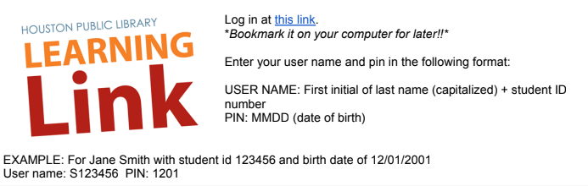
Access academic databases through Houston Public Library using the login instructions above.
See the list all of the databases HPL provides and search for sources at https://houstonlibrary.org/az.php
🦾🤖 AI Research Tools: Elicit & Consensus


Create a free login at Elicit: The AI Research Assistant.
Type your ethical dilemma into the “Ask a research question” search bar and hit enter.
💡 Intro guide to using Elicit’s features for your Reflective Project research linked here!

Screenshot of results using a student’s research question from an IB-provided example:
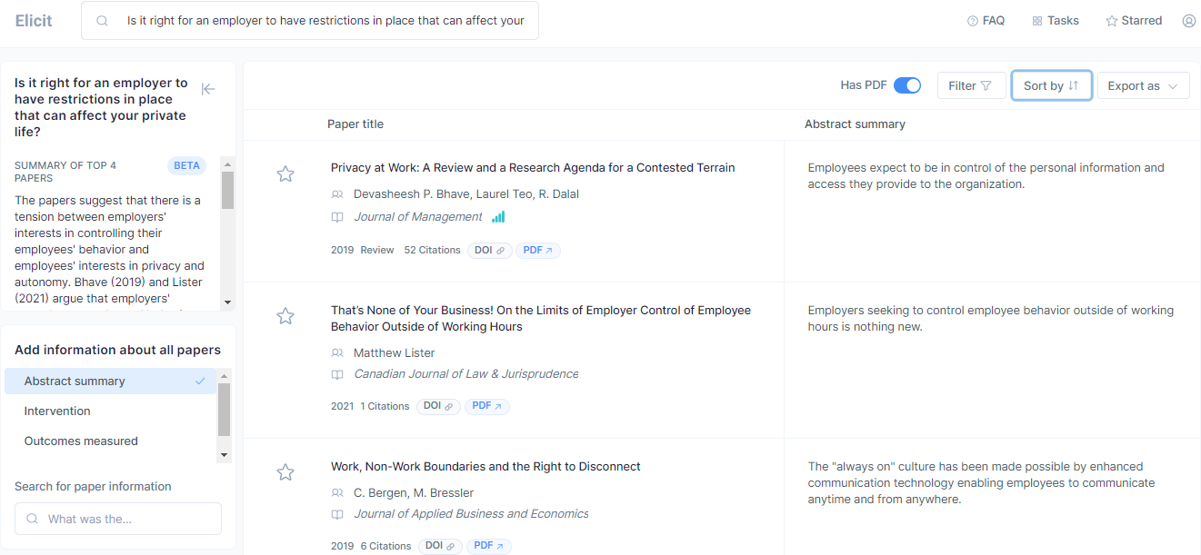

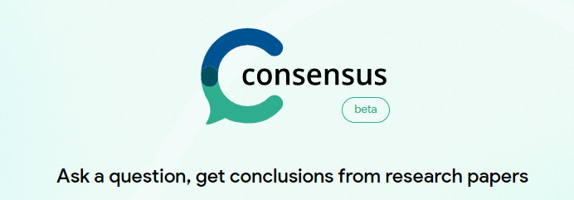

Create a free login at Consensus.app to compare experts’ perspectives on your dilemma.
Type your ethical dilemma in the form of a yes/no research question and Consensus will generate a list of relevant quotations and academic sources.

Screenshot of results using a student’s research question from an IB-provided example:
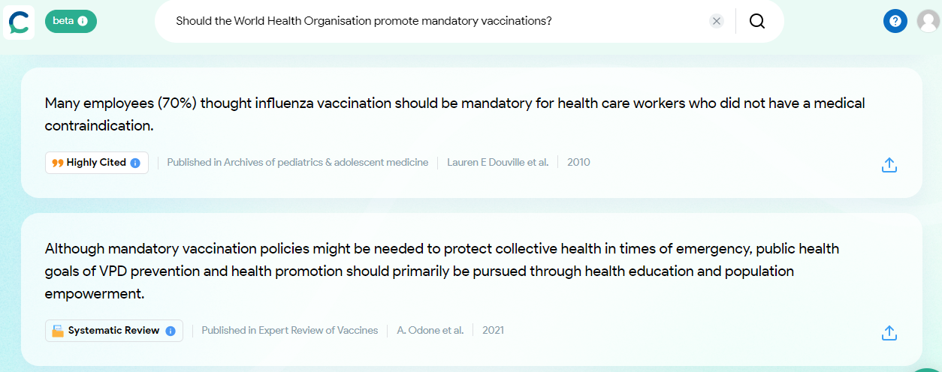

Reflective Project Format Options
You can choose one of two options:
Option 1
A written essay (maximum 3000 words) plus reflections (maximum 1000 words) o Reflections on planning and progress form.
Option 2
A written essay (1500 - 2000 words) accompanied by an additional format (film, oral presentation, interview, play, or display), plus reflections (maximum 1000 words) on the Reflections on planning and progress form.
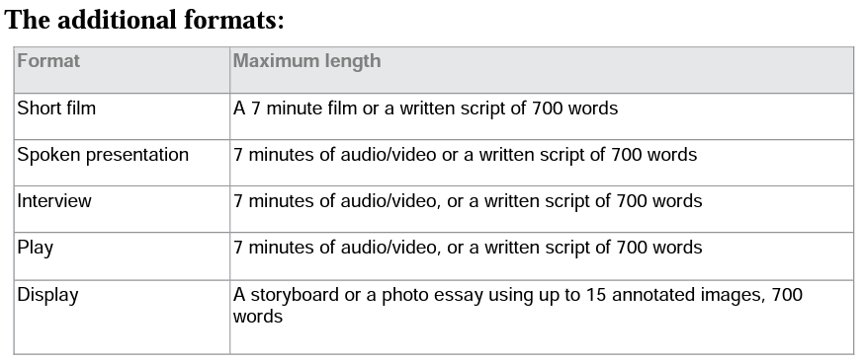

Reflective Project Contents
The following must be included in the reflective project:
- The issue
You must explain the issue and place it in context. But the issue itself is not the primary focus of the reflective project. → Putting in context = using a real, concrete example
- The ethical dilemma
You must examine an ethical dilemma associated with the issue and examine two (or more) perspectives in a fair and equal manner. This is the primary focus of the reflective project.
- The research
You must provide evidence of research that supports the differing viewpoints on the issue and its ethical dilemma.
- An evaluation
You must evaluate the viewpoints on the ethical dilemma and then articulate their own point of view based on reasoned argument.
- References, citations and a bibliography
The reflective project is an academic piece of work and should be presented as such. References, citations and a bibliography ensure intellectual honesty and allow the readers to access the evidence themselves. You should use a consistent style of referencing throughout the reflective project.
Appendices, footnotes and endnotes are not necessary but if you choose to use them you should do so appropriately.
- The RPPF
The RPPF requires you to reflect on the challenges encountered during the reflective project, how these can be overcome (looking forward to the next stage of the reflective project), or how they were overcome and what was learnt from the process and the changes in approach.
The RPPF is used to formally assess Criterion E: Engagement and reflection. It also acts as a record to support the authenticity of your work. Each entry on the RPPF is informed by a meeting with your supervisor, where progress, planning and issues are discussed.

Reflective Project Scoring Criteria
